ENERGY FLOW AND APPLICATION OF THE PRINCIPALS OF THERMODYNAMIC IN LIVING SYSTEM Part I

Energy Flow

The behaviour of the unidirectional flow of energy from sun to various trophic level of biotic system may called Energy Flow
The producers and consumers in ecosystem can be arranged into several feeding groups, each known as trophic level (feeding level).
This energy flow is based on two important Laws of Thermodynamics which are as follows:

(1) The first law of Thermodynamics:
It states that the amount of energy in the universe is constant. It may change from one form to another, but it can neither be created nor destroyed..

(2) The second law of Thermodynamics:
The change of energy, from one form to another, takes place in such a way that a part of energy remains unutilized. In this way, after transformation the capacity of energy to perform work is decreased. Thus, energy flows from higher to lower level.

The ultimate source of energy for biotic system is the Sun. When the light energy falls on the green surfaces of plants, a part of it is transformed into chemical energy which is stored in various organic products in the plants. When the herbivores consume plants as food it gains energy from the Plant. The stored chemical energy in the biomass of the plant is converted into kinetic energy, degradation of energy will occur through its conversion into heat. When herbivores are consumed by carnivores further degradation will occur. Similarly, when primary carnivores are consumed by top carnivores, again energy will be degraded.

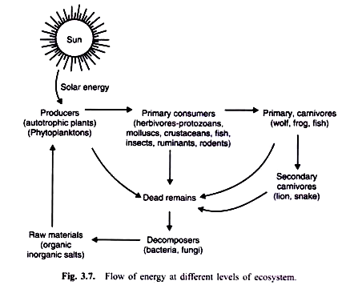

Fig- Flow of energy at different levels of ecosystem

Flow of Energy can be explained by means of two models namely: single channel energy model and Y-shaped energy model.

